**2017 Ningbo University of Trcjnology**

**Weekly Programming Contest**

**Contest Section**

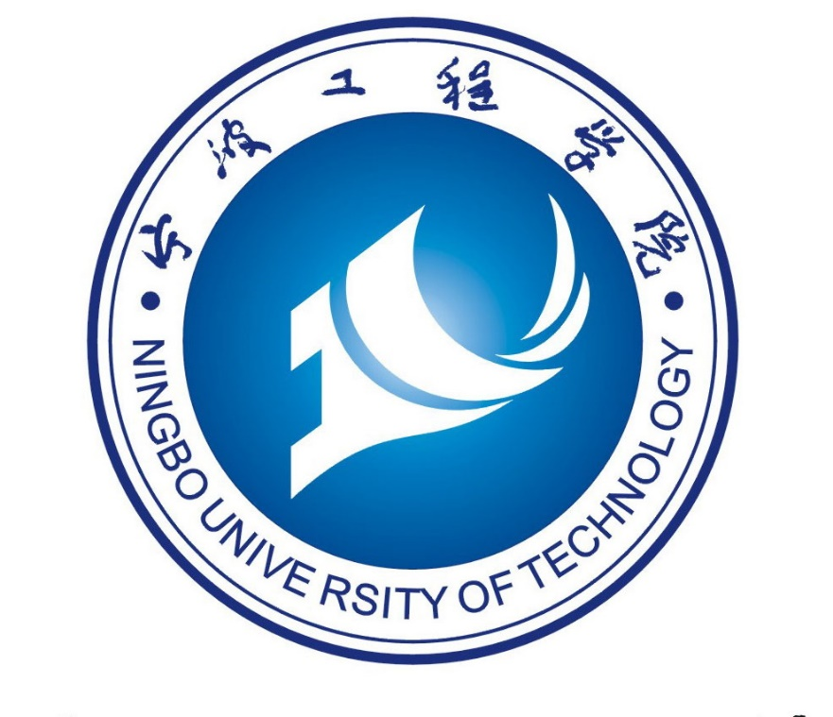

Problem List

|  |  |
| --- | --- |
| A  B  C  D  E  F  G | Scarborough Fair  Wc与整数分组  Night at the Museum  最小公倍数挑战  IP查询  Wc的朗利特树篱迷宫(Ⅲ)  Tic-Tac-Toe |

2017.12.22